Color Vocabulary

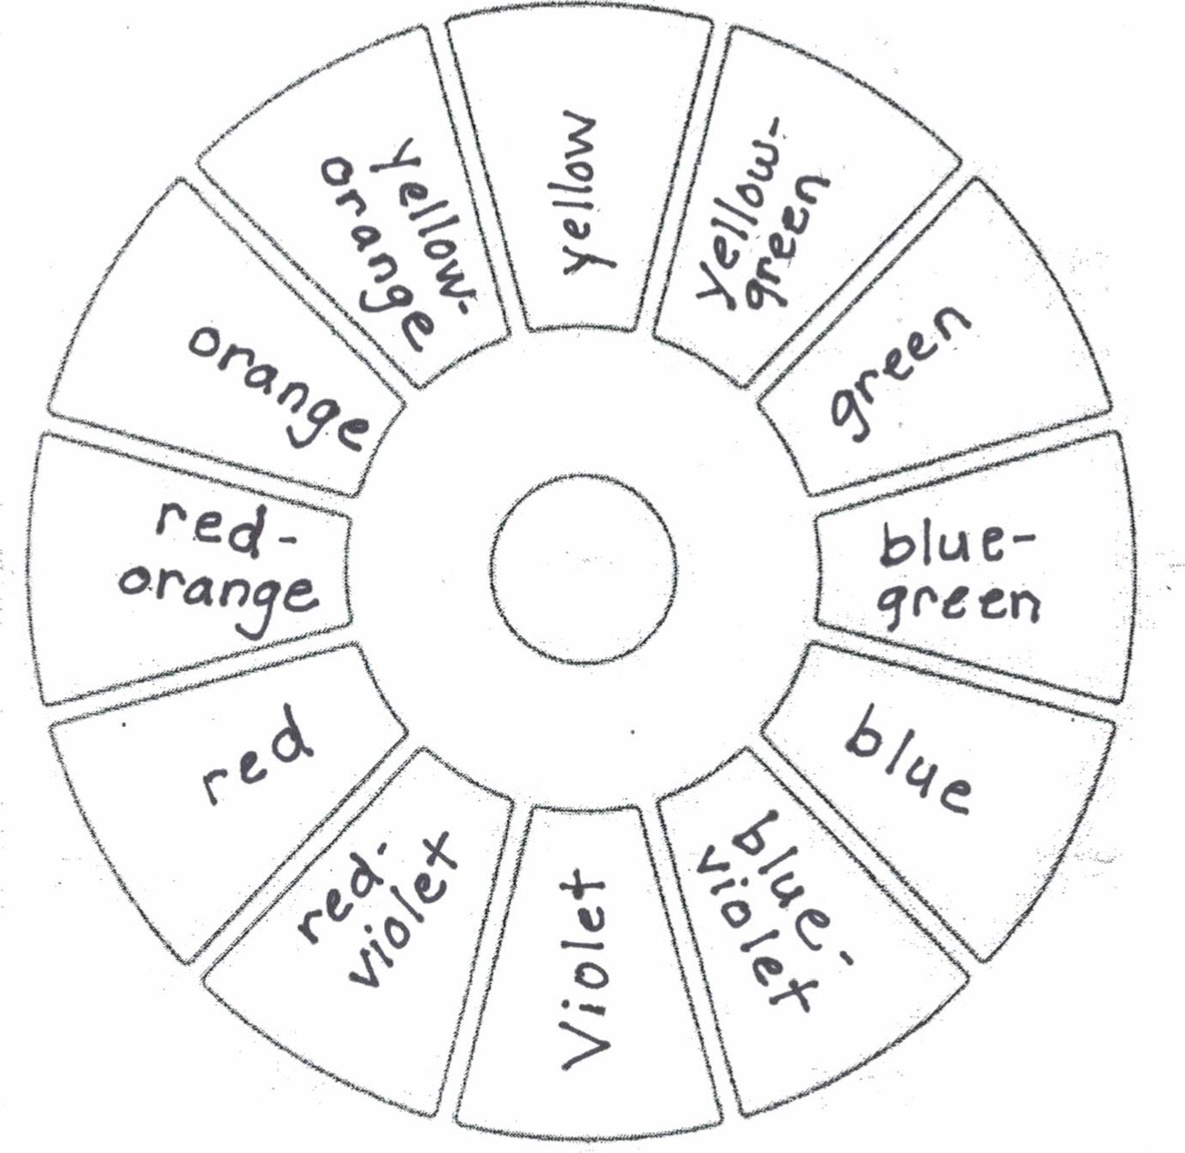
Color is the quality of an object with respect to light reflected by the object, usually determined visually by measurement of hue, saturation, and brightness of the reflected light.
Hue is an individual color.
Primary Colors are those that cannot be made by combining any other colors; primary color pigments can be mixed to make all other colors. The primary colors are yellow, red, and blue.
Secondary Colors are made by mixing two primary colors. The secondary colors are orange, green, and purple.
Tertiary Colors are made by mixing a primary color with one of its nearest secondary colors. The tertiary colors are yellow-orange, red-orange, red-violet, blue-violet, blue-green, and yellow-green.
Complementary Colors are colors that are opposite each other on the color wheel. They are high contrast when used together in a composition. Red and green, yellow and purple, and blue and orange are complementary. Browns can be made by mixing two complementary colors together; greys can be made by mixing two complementary colors together and adding white.
Analogous Colors Analogous colors are groups of three colors that are next to each other on the color wheel, sharing a common color, with one being the dominant color, which tends to be a primary or secondary color, and a tertiary. They are compatible and blend well when used in a composition. Red, red-violet, and violet are analogous.
Monochromatic Color is a color scheme that uses only one hue and all the values (tints and shades) of the hue.
Split Complementary Color is a color scheme that uses a base color and two analogous colors on either side of the base’s complement.
Warm Colors are vivid and energetic. They advance in space and can pop out in a composition. Warm colors include yellow, red, and orange.
Cool Colors are serene and soothing. They recede in a composition so fall into the background easily. Cool colors include blue, green, and violet.
Monochromatic Colors are the tints and shades of one hue.
Tints are the high, lighter values of a color. A tint is made by adding white to a hue, making the color lighter.
Shades are the low, darker values of a color. A shade is made by adding black to a hue, making the color darker.
Saturation is the brightness or dullness of a color. A highly saturated color is very bright while a desaturated color is very dull.

